**Process Model for Infusion Pump**

**V MODEL with AGILE SCRUM**

The entire team will work as one self-organising cross functional scrum team.

Scrum Master and Safety Manager will overlook the entire project. Product backlog will be divided into two different backlogs functional and safety requirements. There will be prioritisation of the requirements in each planning meeting which should ideally include the entire team and also the Product Owner (if possible).

All the phases listed in the safety standard IEC-61508 will be followed. There will be a mapping of the phases of the safety standard along with the AGILE methodologies. All the steps in the safety standard needs to be followed mandatorily but AGILE processes are optional. In case of conflict priority will be given to the safety standard.

The project development will be split into sprints of 1-2 weeks. There will be sprint planning meeting 1 day before the start of the sprint. This will be followed by the sprint work which will include requirement analysis, design, development and testing. There are usually daily scrum meetings to monitor the progress, but in our case, it can be replaced by bi-weekly meetings. A sprint will be marked as complete only if all the tasks associated with it has been completed and validated. The QA should also be from safety point of view. There will be system testing after every sprint and progress will be displayed in the form of a DEMO (internally within the team/ preferable with PO). The last day of sprint will have a sprint retrospective meeting and can also have a sprint backlog meeting to prioritise the remaining features (this step may be merged in sprint planning due to time constraints).

The team members are considered cross-functional. Each team member will act as developer as well as tester within every sprint. The developer and tester must document the requirement analysis and test cases must be prepared and documented accordingly. The developer should document the Technical Design Document (TDD). Unit testing has to be done by the developer and there has to be code review before testing phase within the sprint. Test cases should be marked as pass/fail before the end of the sprint.

Mapping AGILE SCRUM to SAFETY STANDARD:

The Product Backlog from Scrum method will be applied for the SW safety requirements specification additionally. The Sprint Review and Sprint Retrospective element from Scrum will be applied for the Software safety lifecycle step of SW aspects of system safety validation, as well, to facilitate stakeholder involvement and continuous improvement of the product and process.

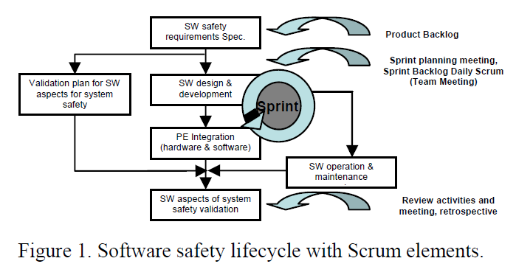

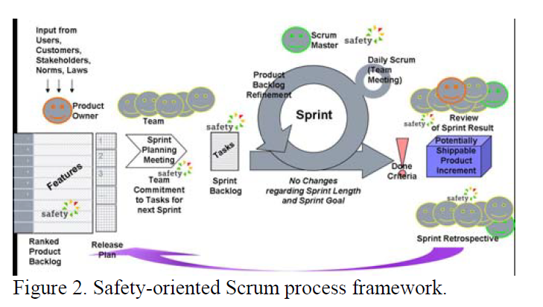

Two factors that make it difficult to implement AGILE for the development of SCS:

1. Everybody has licence to change anything – this is handled by proper monitoring (safety manager), review process, validation and verification.
2. Working software over comprehensive documentation – this is handled by enabling comprehensive documentation on a sprint wise basis. Traceability is also taken care of.

Features that could be useful for real world projects but cannot be implemented in our project (due to time and effort constraints):

1. Test automation
2. Automatic document creation
3. Using tools to trace requirements

References:

An Integrated Process for Developing Safety-critical Systems using Agile Development Methods: Zhensheng Guo, Claudia Hirschmann, ICSEA 2012 : The Seventh International Conference on Software Engineering Advances (images taken from this source as well)